Johnstown Common Council
Budget Workshop - Council Chambers, City Hall
Wednesday, October 13, 2021 @ 6:00 p.m.

MINUTES

The proceedings of this meeting were taped for the benefit of the City Clerk; the minutes are not a verbatim record of the proceedings, therefore the minutes are not a word-for-word transcript.

CALL MEETING TO ORDER – Craig Talarico, Council Member-at-Large

ROLL CALL OF COUNCIL – Craig Talarico, Council Member-at-Large

IN ATTENDANCE:
☒Craig Talarico, Council Member-at-Large
☒Bradley Hayner, Council Member Ward 1
☒Kathi Iannotti, Council Member Ward 2
☒Eric Parker, Council Member Ward 3
☒Max Spritzer, Council Member Ward 4
MOTION TO ADJOURN at 7:25 p.m.
Council Member Iannotti
Seconded – Council Member Parker
Ayes: 5
Noes: 0
Absent: 0
Abstain: 0

Respectfully submitted,
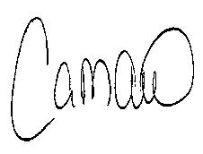
Carrie M. Allen
City Clerk

