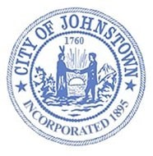
City of Johnstown
PO Box 160, 33-41 East Main Street
Johnstown, New York 12095
Phone: (518) 736-4011 • Fax: (518) 736-4032
www.cityofjohnstown.ny.gov

MASS NOTIFICATIONS

The City of Johnstown has implemented the CivicPlus® Mass Notification System to send both emergency and non-emergency alerts to residents.
Examples of messages sent through the Mass Notification System may include, but not limited to, boil water notices, police or fire emergencies, street closures, and garbage collection.

Subscribers can register to receive alerts via text messages and/or email.

HOW TO SUBSCRIBE:
- Go to: https://cityofjohnstown.ny.gov
- Scroll down to Quick Links
- Click:

- Click Sign Up for Notifications
- Provide your information

- Click Sign Me Up

- Please make sure you confirm your account to ensure you are receiving notifications

You can also:

Text JohnstownNY to 38276 to sign up for text messages.

and / or

Download the myAlerts app on your cell phone.

Should you have any questions or need assistance signing up for this service please contact the City Clerk’s office at 518-736-4011.

