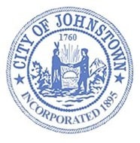
Johnstown Planning Board
Council Chambers, City Hall
Wednesday, July 5, 2023 @ 4:00 p.m.

AGENDA

- CALL MEETING TO ORDER

- APPROVE MINUTES
- June 6, 2023

- SITE PLAN REVIEW
  - Seven Brew Coffee
Route 30A / N. Comrie Avenue, Johnstown

- DISCUSSION

- ADJOURN

