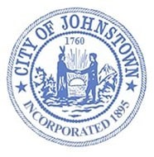
Johnstown Planning Board
Council Chambers, City Hall
Tuesday, March 7, 2023 @ 4:00 p.m.

AGENDA

- CALL MEETING TO ORDER

- APPROVE MINUTES
- February 7, 2023

- PUBLIC HEARING
  - Popeye’s Restaurant
252 North Comrie Avenue, Johnstown

- SITE PLAN REVIEW
  - Second Wind Coffee, LLC
132 W. Main Street, Johnstown

- DISCUSSION

- ADJOURN

