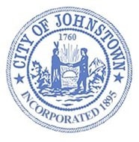
Johnstown Planning Board
Council Chambers, City Hall
Tuesday, November 1, 2022 @ 4:00 p.m.

AGENDA

- CALL MEETING TO ORDER

- APPROVE MINUTES
- October 4, 2022

- PUBLIC HEARING
  - Sacandaga Properties, LLC; 75-81 Briggs Street
3000 Sq. Ft. addition to existing building

- DISCUSSION

- ADJOURN

