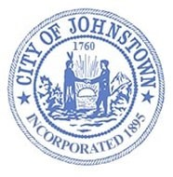
Johnstown Common Council
Special Meeting - Council Chambers, City Hall
Friday, July 29, 2022 @ 8:00 a.m.

AGENDA

We will broadcast using Facebook Live. The public can view the meeting from the official City of Johnstown Facebook page: City of Johnstown, New York

- CALL MEETING TO ORDER / PLEDGE OF ALLEGIANCE

- ROLL CALL OF COUNCIL

- PUBLIC SESSION –
Any person wishing to address the Council regarding city business will be permitted to speak for three (3) minutes. A council member will monitor Facebook during the session and read comments to the Council. There is no exchange of dialogue during this portion of the meeting. Profane language, obscene conduct, or disruptive comments are not acceptable and will not be allowed.

- LOCAL LAW
- Local Law #1 - Amend City Charter to abolish Water Board

- RESOLUTIONS
- Contract between City of Johnstown & Water Board

- DISCUSSION

- EXECUTIVE SESSION – Only if necessary

- ADJOURN

