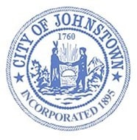
Johnstown Planning Board
Council Chambers, City Hall
Tuesday, March 5, 2024 @ 4:00 p.m.

AGENDA

- CALL MEETING TO ORDER

- APPROVE MINUTES
- February 6, 2024

- SITE PLAN REVIEW
  - Deli Master; 14 Industrial Parkway

- ADJOURN

